Please follow this guide to configure outlook express for smartconnexions Email
Ids:
Open Outlook Express and select Tools. Click "Accounts...”
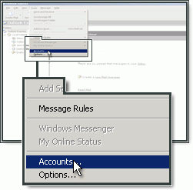
Click "Add" and choose "Mail...".
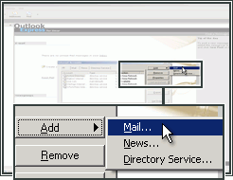
Type your Name (this will be shown when people receive a message from you).
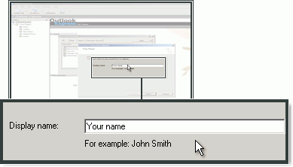

Type the E-mail address, created in the control panel, and click "Next".
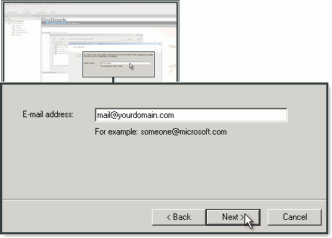
It would be EmailIDLogin@smartconnexions.in

Choose POP3 as your account type.
In incoming mail (pop3), enter pop.smartconnexions.in
For SMTP server (outgoing server), enter customer-smtp.one.com and click "Next".
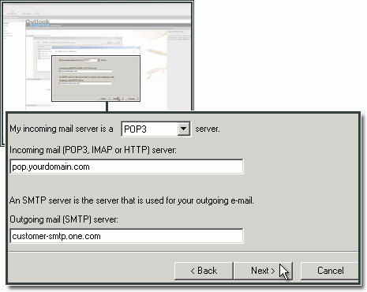
Type the e-mail address (Eg: EmailID@smartconnexions.in)and password that you created in the control panel and click "Next".
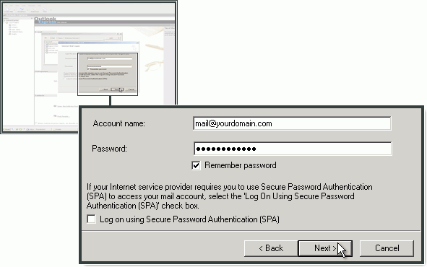
Click "Finish" to complete the setup.
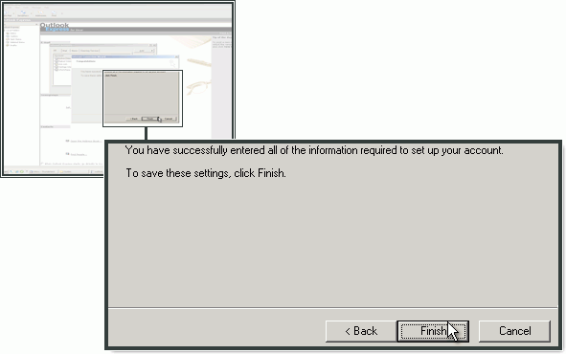

Configuration of SMTP server in Outlook Express

Open Accounts panel:
Tools->Accounts
Mark the mail account in the list and click "Properties".
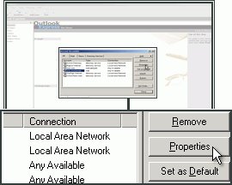
Select the "Servers" tab.
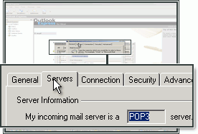
Check "My server requires authentication" if it is not already checked.
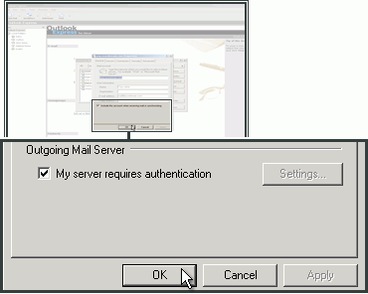
Select the Advanced tab.
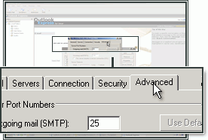
In "Outgoing server (SMTP)" enter 2525.
Click "OK".
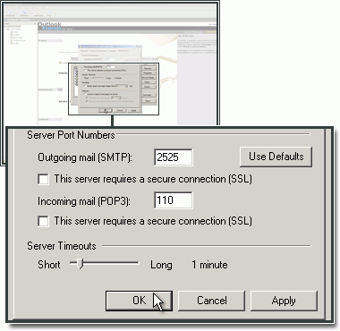

If you find any difficulties, please mail across to:
info@crea2ive.com
Regards,
Crea2ive Team

